**Practical Number 15: Build a web application to create and use WCF service in ASP.net**

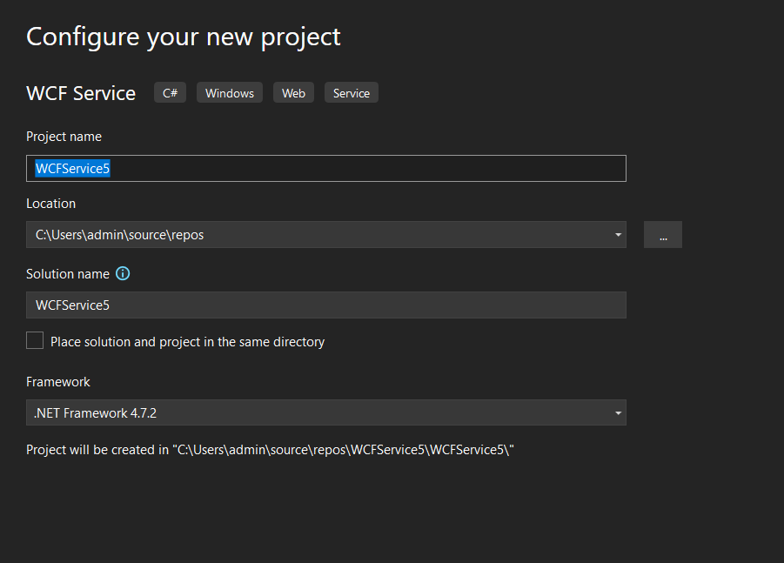

Iservice.cs

using System;

using System.Collections.Generic;

using System.Linq;

using System.Runtime.Serialization;

using System.ServiceModel;

using System.ServiceModel.Web;

using System.Text;

// NOTE: You can use the "Rename" command on the "Refactor" menu to change the interface name "IService" in both code and config file together.

[ServiceContract]

public interface IService

{

[OperationContract]

string GetData(int value);

[OperationContract]

double add(double a, double b);

[OperationContract]

double sub(double a, double b);

[OperationContract]

double mul(double a, double b);

[OperationContract]

double div(double a, double b);

[OperationContract]

CompositeType GetDataUsingDataContract(CompositeType composite);

// TODO: Add your service operations here

}

// Use a data contract as illustrated in the sample below to add composite types to service operations.

[DataContract]

public class CompositeType

{

bool boolValue = true;

string stringValue = "Hello ";

[DataMember]

public bool BoolValue

{

get { return boolValue; }

set { boolValue = value; }

}

[DataMember]

public string StringValue

{

get { return stringValue; }

set { stringValue = value; }

}

}

Servics.cs

using System;

using System.Collections.Generic;

using System.Linq;

using System.Runtime.Serialization;

using System.ServiceModel;

using System.ServiceModel.Web;

using System.Text;

// NOTE: You can use the "Rename" command on the "Refactor" menu to change the class name "Service" in code, svc and config file together.

public class Service : IService

{

public string GetData(int value)

{

return string.Format("You entered: {0}", value);

}

public double add(double a, double b)

{

return a + b;

}

public double sub(double a, double b)

{

return a - b;

}

public double mul(double a, double b)

{

return a * b;

}

public double div(double a, double b)

{

return a / b;

}

public CompositeType GetDataUsingDataContract(CompositeType composite)

{

if (composite == null)

{

throw new ArgumentNullException("composite");

}

if (composite.BoolValue)

{

composite.StringValue += "Suffix";

}

return composite;

}

}

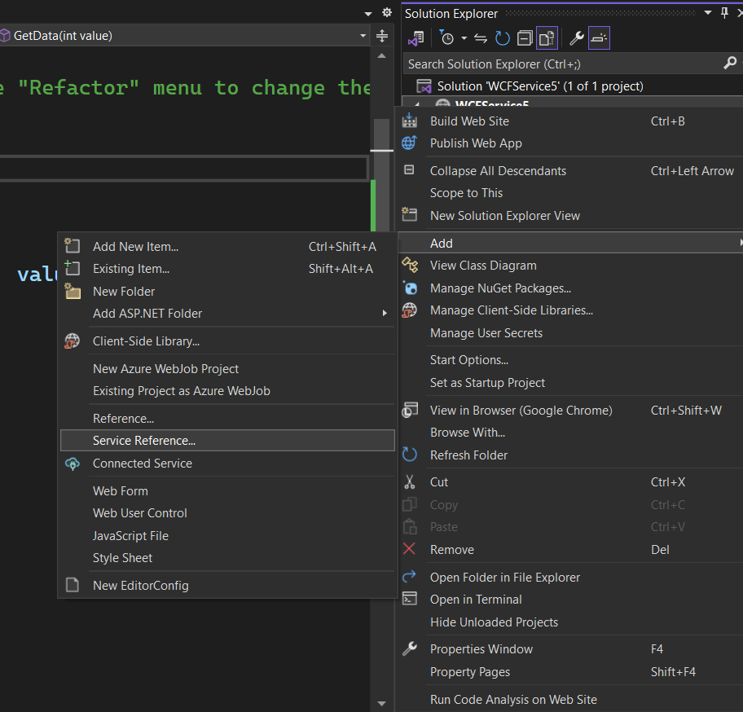

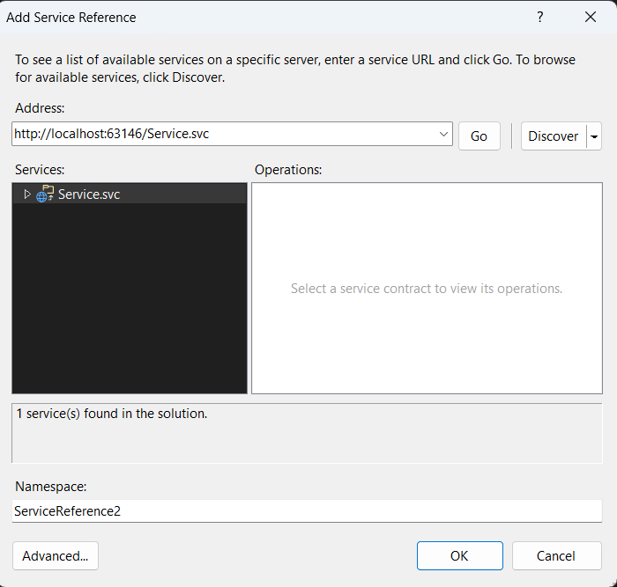

WebForm.cs

using System;

using System.Collections.Generic;

using System.Linq;

using System.Web;

using System.Web.UI;

using System.Web.UI.WebControls;

public partial class _Default : System.Web.UI.Page

{

ServiceReference1.ServiceClient service = new ServiceReference1.ServiceClient();

protected void Page_Load(object sender, EventArgs e)

{

}

protected void Button1_Click(object sender, EventArgs e)

{

double a = Convert.ToDouble(TextBox1.Text);

double b = Convert.ToDouble(TextBox2.Text);

double result= service.add(a, b);

Label1.Text = "Addition" + result.ToString();

}

protected void Button2_Click(object sender, EventArgs e)

{

double a = Convert.ToDouble(TextBox1.Text);

double b = Convert.ToDouble(TextBox2.Text);

double result = service.sub(a, b);

Label1.Text = "Subtraction" + result.ToString();

}

protected void Button3_Click(object sender, EventArgs e)

{

double a = Convert.ToDouble(TextBox1.Text);

double b = Convert.ToDouble(TextBox2.Text);

double result = service.mul(a, b);

Label1.Text = "Multiplication" + result.ToString();

}

protected void Button4_Click(object sender, EventArgs e)

{

double a = Convert.ToDouble(TextBox1.Text);

double b = Convert.ToDouble(TextBox2.Text);

double result = service.div(a, b);

Label1.Text = "Division" + result.ToString();

}

}

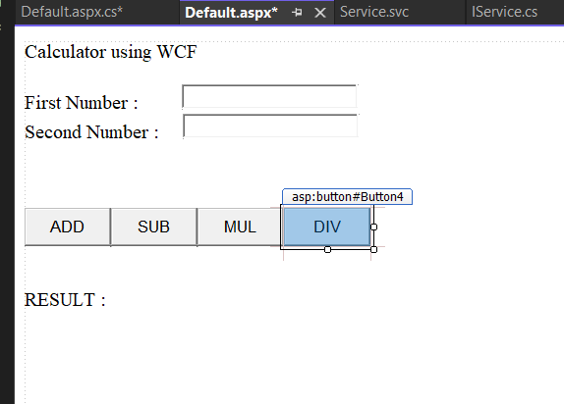

<%@ Page Language="C#" AutoEventWireup="true" CodeFile="Default.aspx.cs" Inherits="_Default" %>

<!DOCTYPE html>

<html xmlns="http://www.w3.org/1999/xhtml">

<head runat="server">

<title></title>

</head>

<body>

<form id="form1" runat="server">

<div>

Calculator using WCF<br />

<br />

First Number :<asp:TextBox ID="TextBox1" runat="server" style="margin-left: 44px" Width="171px"></asp:TextBox>

<br />

Second Number :

<asp:TextBox ID="TextBox2" runat="server" style="margin-left: 19px" Width="171px"></asp:TextBox>

<br />

<br />

<br />

<br />

<asp:Button ID="Button1" runat="server" Height="39px" OnClick="Button1_Click" Text="ADD" Width="88px" />

<asp:Button ID="Button2" runat="server" Height="39px" OnClick="Button2_Click" Text="SUB" Width="88px" />

<asp:Button ID="Button3" runat="server" Height="39px" OnClick="Button3_Click" Text="MUL" Width="88px" />

<asp:Button ID="Button4" runat="server" Height="39px" OnClick="Button4_Click" Text="DIV" Width="88px" />

<br />

<br />

<br />

<asp:Label ID="Label1" runat="server" Text="RESULT :"></asp:Label>

<br />

<br />

<br />

<br />

<br />

<br />

<br />

</div>

</form>

</body>

</html>

OUTPUT:

